**1. High Level Design :**  
High Level Design in short HLD is the general system design means it refers to the overall system design. It describes the overall description/architecture of the application. It includes the description of system architecture, data base design, brief description on systems, services, platforms and relationship among modules. It is also known as macro level/system design. It is created by solution architect. It converts the Business/client requirement into High Level Solution. It is created first means before Low Level Design.

**2. Low Level Design :**  
Low Level Design in short LLD is like detailing HLD means it refers to component-level design process. It describes detailed description of each and every module means it includes actual logic for every system component and it goes deep into each modules specification. It is also known as micro level/detailed design. It is created by designers and developers. It converts the High Level Solution into Detailed solution. It is created second means after High Level Design.

**3. Front end developer:**

A front-end developer is a web developer that codes the front end of a website. While web design is the way a website looks, front end development is how that design actually gets implemented on the web.

**4.client:**

A client is the receiving end of a service or the requestor of a service in a client/server model type of system. The client is most often located on another system or computer, which can be accessed via a network. This term was first used for devices that could not run their own programs, and were connected to remote computers that could via a network. These were called dumb terminals and they were served by time-sharing mainframe computers.

**5.Backend Developer:**

The backend of a website consists of a server, an application, and a database. A backend developer builds and maintains the technology that powers those components which, together, enable the user-facing side of the website to even exist in the first place

**6.Server:**

In computing, a server is a piece of computer hardware or software that provides functionality for other programs or devices, called clients. This architecture is called the client–server model. Servers can provide various functionalities, often called "services", such as sharing data or resources among multiple clients, or performing computation for a client. A single server can serve multiple clients, and a single client can use multiple servers. A client process may run on the same device or may connect over a network to a server on a different device. Typical servers are database server, file servers, mail servers, print servers, web servers, game servers, and application servers

**7**.**Frame work:**

Since they are often built, tested, and optimized by several experienced software engineers and programmers, software frameworks are versatile, robust, and efficient.

Using a software framework to develop applications lets you focus on the high-level functionality of the application. This is because any low-level functionality is taken care of by the framework itself.

Developing software is a complex process. It necessitates a plethora of tasks, including coding, designing, and testing. For only the coding part, programmers had to take care of the syntax, declarations, garbage collection, statements, exceptions, and more.

**8.Client server architecture:**

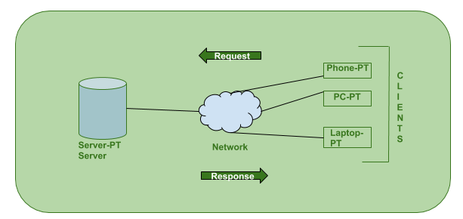

.

**9.Data base:**

A database is an organized collection of structured information, or data, typically stored electronically in a computer system. A database is usually controlled by a database management system . Together, the data and the DBMS, along with the applications that are associated with them, are referred to as a database system, often shortened to just database.

This is because the database stores all the pertinent details about the company such as employee records, transactional records, salary details etc.